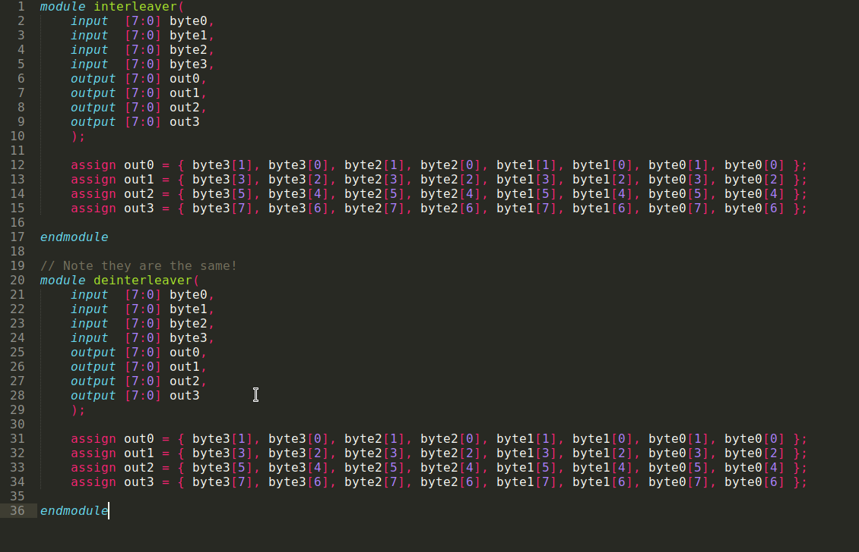
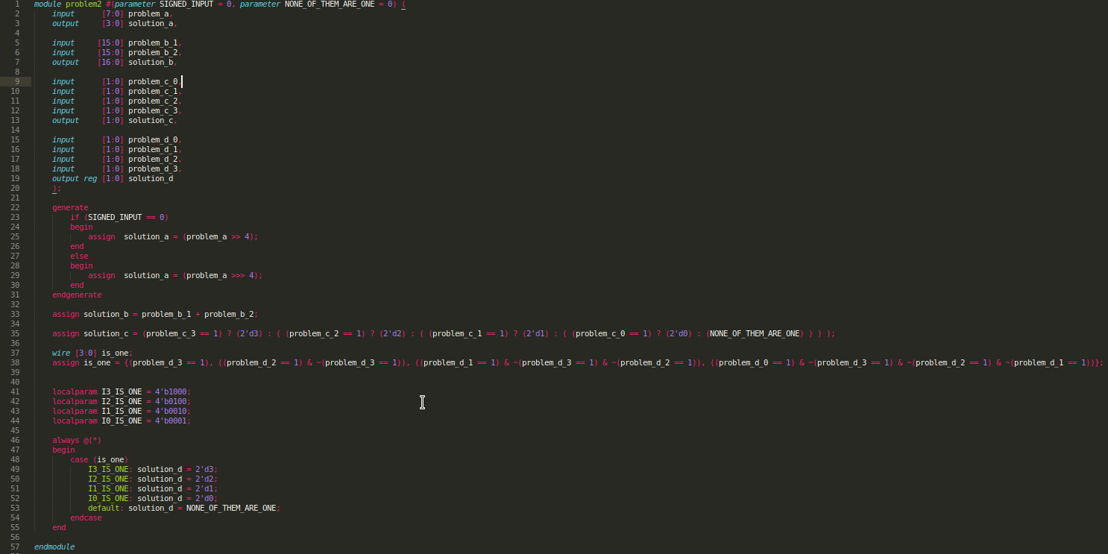
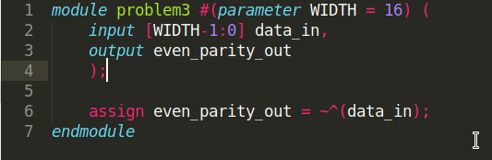

module problem1_tb;
wire [7:0] byte0;
wire [7:0] byte1;
wire [7:0] byte2;
wire [7:0] byte3;
wire [7:0] out0;
wire [7:0] out1;
wire [7:0] out2;
wire [7:0] out3;

assign byte0 = 8'h00;
assign byte1 = 8'h0E;
assign byte2 = 8'h8C;
assign byte3 = 8'h03;

interleaver i1 (
.byte0(byte0),
.byte1(byte1),
.byte2(byte2),
.byte3(byte3),
.out0(out0),
.out1(out1),
.out2(out2),
.out3(out3)
);

initial
begin
$dumpfile("test.vcd");
$dumpvars(0,problem1_tb);
#10;
end

endmodule

module problem2_tb;

wire [7:0] problem_a;
wire [3:0] solution_a;
wire [3:0] solution_a2;
wire [15:0] problem_b_1;
wire [15:0] problem_b_2;
wire [16:0] solution_b;
wire [16:0] solution_b2;
wire [1:0] problem_c_0;
wire [1:0] problem_c_1;
wire [1:0] problem_c_2;
wire [1:0] problem_c_3;
wire [1:0] solution_c;
wire [1:0] solution_c2;
wire [1:0] problem_d_0;
wire [1:0] problem_d_1;
wire [1:0] problem_d_2;
wire [1:0] problem_d_3;
wire [1:0] solution_d;
wire [1:0] solution_d2;

reg [7:0] op1;
reg [15:0] op2a;
reg [15:0] op2b;

reg [1:0] i0;
reg [1:0] i1;
reg [1:0] i2;
reg [1:0] i3;

assign problem_a = op1;
assign problem_b_1 = op2a;
assign problem_b_2 = op2b;
assign problem_c_0 = i0;
assign problem_c_1 = i1;
assign problem_c_2 = i2;
assign problem_c_3 = i3;
assign problem_d_0 = i0;
assign problem_d_1 = i1;
assign problem_d_2 = i2;
assign problem_d_3 = i3;

problem2 #(.SIGNED_INPUT(0)) p2a(
.problem_a(problem_a),
.solution_a(solution_a),
.problem_b_1(problem_b_1),
.problem_b_2(problem_b_2),
.solution_b(solution_b),
.problem_c_0(problem_c_0),
.problem_c_1(problem_c_1),
.problem_c_2(problem_c_2),
.problem_c_3(problem_c_3),
.solution_c(solution_c),
.problem_d_0(problem_d_0),
.problem_d_1(problem_d_1),
.problem_d_2(problem_d_2),
.problem_d_3(problem_d_3),
.solution_d(solution_d)
);

problem2 #(.SIGNED_INPUT(1), .NONE_OF_THEM_ARE_ONE(3)) p2b(
.problem_a(problem_a),
.solution_a(solution_a2),
.problem_b_1(problem_b_1),
.problem_b_2(problem_b_2),
.solution_b(solution_b2),
.problem_c_0(problem_c_0),
.problem_c_1(problem_c_1),
.problem_c_2(problem_c_2),
.problem_c_3(problem_c_3),
.solution_c(solution_c2),
.problem_d_0(problem_d_0),
.problem_d_1(problem_d_1),
.problem_d_2(problem_d_2),
.problem_d_3(problem_d_3),
.solution_d(solution_d2)
);

initial
begin
$dumpfile("test.vcd");
$dumpvars(0,problem2_tb);
#10;

op1 = 8'd16;
op2a = 16'd5;
op2b = 16'd127;
i0 = 1;
i1 = 1;
i2 = 1;
i3 = 1;
#10;

op1 = 8'b10100111;
op2a = 16'd456;
op2b = 16'd123;
i0 = 1;
i1 = 3;
i2 = 3;
i3 = 3;

#10;
i0 = 1;
i1 = 1;
i2 = 3;
i3 = 3;

#10;
i0 = 1;
i1 = 0;
i2 = 1;
i3 = 0;

#10;
end

endmodule
module problem3_tb;

reg [15:0] data;
wire even_parity;

problem3 p3(
.data_in(data),
.even_parity_out(even_parity)
);

initial
begin
$dumpfile("test.vcd");
$dumpvars(0,problem3_tb);
#10;

data = 16'b11111;

#10;

data = 16'b1111;

#10;
end
endmodule

